Rayat Shikshan Sanstha’s
Arts and Commerce College,
Madha, Tal. Madha, Dist.-Soalpur-413 209
FACULTY PROFILE

Name Dr. N.V. Shinde  Designation : Assitant Professor  Department : Marathi  Specialization : Feminist Literature and Dalit, Gramin  e-mail : shindenamdeo77@gmail.com  Telephone :  Mobile No : 9850125584 |  |  |  |  | Photo 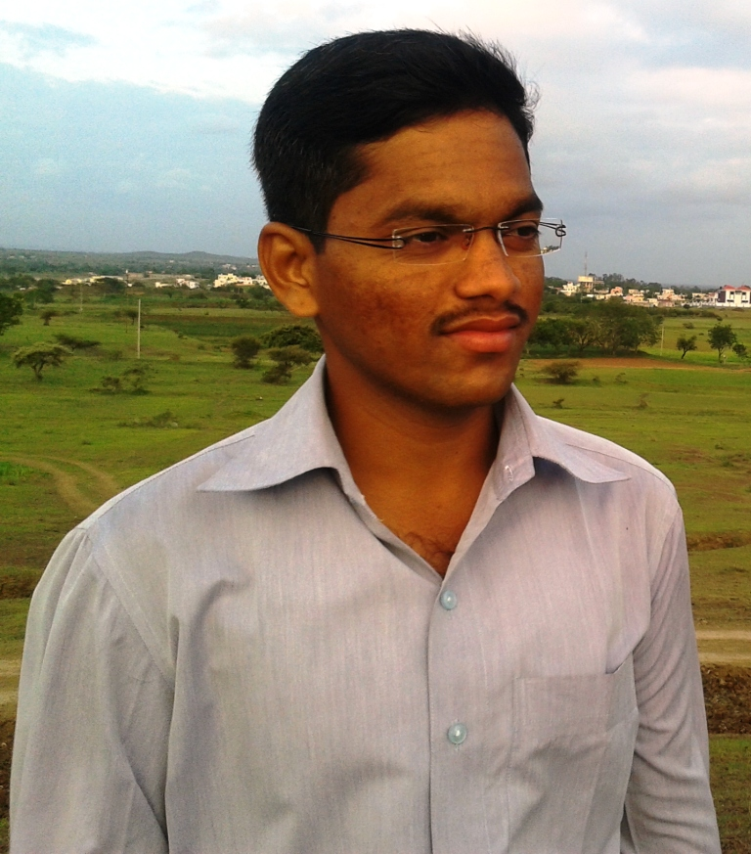
ACADEMIC RECORD:
- Ph.D. : 2018
- Title of Thesis : uOonksRrjh xzkeh.k dkO;laxzgkarhy d`f”klaLd`rhpk vH;kl
- M. A. / M.Com. : M.A. in Marathi and M.A. in English
- B.A. / B.Com. : B.A. 2007

TEACHING AND ADMINSTRATIVE EXPERIENCE: |  | - Total Teaching Experience : 08 Years  - Total Teaching Experience for U.G : 08 Years  - Total Teaching Experience for P.G. : 01 Years  - Total Research Experience : 07 Years  - Controller of Examinations : NA
RESEARCH AREA OF INTEREST |  | 1. Feminist Literature  2. Skilll development and language Taching  3. Sant Sahitya, E content development etc.
AWARDS, HONORS, SCHOLARSHIPS & FELLOWSHIPS :
1.A.P. Sonalakar Prize
2.
3.
RESEARCH RECORD AS A  M. Phil./ Ph.D. |  |  | M.Phil.- 2011  Ph.D. - 2018
PAPER PUBLISHED IN THE NATIONAL AND INTERNATIONAL JOURNALS |  |  |  | International : 02  National : 07
PAPER PRESENTED IN NATIONAL/INTERNATIONAL CONFERENCES /SYMPOSIA/SEMINARS/WORKSHOPS |  |  |  | International : 06  National : 11
NATIONAL/INTERNATIONAL CONFERENCES/SYMPOSIA/SEMINARS/ WORKSHOPS ATTENDED |  |  |  | International : 03  National : 08
REFERENCE BOOKS /BOOKS CHAPTER PUBLISHED WITH NATIONAL/ INTERNATIONAL PUBLISHERS |  |  |  | International : 00  National : 02
Text Books Published with National Publishers |  |  |  | 04
RESEARCH PROJECTS | Ongoing : Nil  Completed : 01
SKILLS AND EXPERTISE :
- Use of ICT in Teaching
- Skill development and Language education

FEATURED PUBLICATIONS DURING LAST FIVE YEARS:
(Add publications having impact Factor more than 2 or more than 2)
- Language teaching: Benchmarking
- Jagtikikaran aani Gramin sahitya
- Novodattari Gramin Kavyasangrahatil Pryavaraniy Bhan

- Marathi bhasa aani Kousyala vikas

(Dr. N.V. Shinde)

