Rayat Shikshan Sanstha’s
Arts and Commerce College,
Madha, Tal. Madha, Dist.-Soalpur-413 209
FACULTY PROFILE

Name : Smt. R. R. Kodag  Designation : Assistant Professor  Department : Commerce  Specialization : Statistics (M.Sc.)  e-mail : rashmi.kodag13@gmail.com  Telephone : ---  Mobile No : 9552495755 |  |  |  |  | 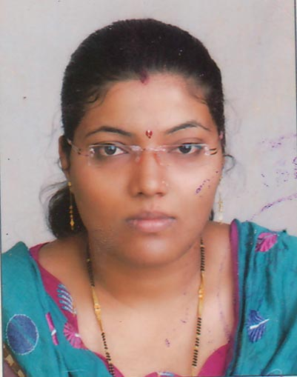  Photo
ACADEMIC RECORD:
- Ph.D. : Nil
- Title of Thesis : Nil
- M. A. / M.Com. : Nil
- B.A. / B.Com. : Nil

TEACHING AND ADMINSTRATIVE EXPERIENCE: |  | - Total Teaching Experience : 4 Years  - Total Teaching Experience for U.G : 4 Years  - Total Teaching Experience for P.G. : ----  - Total Research Experience : ----  - Controller of Examinations : ----
RESEARCH AREA OF INTEREST |  | 1. Statistics  2.  3.
AWARDS, HONORS, SCHOLARSHIPS & FELLOWSHIPS :
1.Nil
2. Nil
3. Nil
RESEARCH RECORD AS A  M. Phil./ Ph.D. |  |  | Nil
PAPER PUBLISHED IN THE NATIONAL AND INTERNATIONAL JOURNALS |  |  |  | International : Nil  National : Nil
PAPER PRESENTED IN NATIONAL/INTERNATIONAL CONFERENCES /SYMPOSIA/SEMINARS/WORKSHOPS |  |  |  | International : Nil  National : Nil
NATIONAL/INTERNATIONAL CONFERENCES/SYMPOSIA/SEMINARS/ WORKSHOPS ATTENDED |  |  |  | International : Nil  National :2
REFERENCE BOOKS /BOOKS CHAPTER PUBLISHED WITH NATIONAL/ INTERNATIONAL PUBLISHERS |  |  |  | International : Nil  National : Nil
Text Books Published with National Publishers |  |  |  | Nil
RESEARCH PROJECTS | Ongoing : Nil  Completed : Nil
SKILLS AND EXPERTISE :
- Nil
- Nil
- Nil
- Nil

- Nil
FEATURED PUBLICATIONS DURING LAST FIVE YEARS:
(Add publications having impact Factor more than 2 or more than 2)
- Nil
- Nil
- Nil

- Nil

- Nil

