Rayat Shikshan Sanstha’s
Arts and Commerce College,
Madha, Tal. Madha, Dist.-Soalpur-413 209
FACULTY PROFILE

Name : Mr. Govardhan K. Dikonda  Designation : Assistant Professor  Department : History  Specialization : Medieval and Modern Indian History  e-mail : govardhandikonda@gmail.com  Telephone :  Mobile No. : 09021207336 |  |  |  |  | 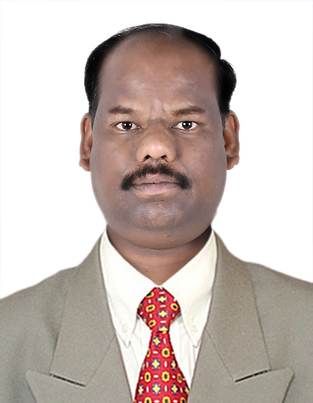
ACADEMIC RECORD:
- Ph.D. : Pursuing in Shivaji University, Kolhapur
- Title of Thesis : पश्चिम भारतातील लेखन व कागद यांचा इतिहास (इ.स. १६०० ते इ.स. १८६०)
- M. A. / M.Com. : 73.83%, 2005, Shivaji University, Kolhapur
- B.A. / B.Com. : 60.00%, 2003, Shivaji University, Kolhapur
- NET/SET : NET with JRF, December 2009

TEACHING AND ADMINSTRATIVE EXPERIENCE: |  | - Total Teaching Experience : 9 Years  - Total Teaching Experience for U.G : 9 Years  - Total Teaching Experience for P.G. : N. A.  - Total Research Experience : N. A.  - Controller of Examinations : N. A.
RESEARCH AREA OF INTEREST |  | 1. Medieval Indian History  2. Modern Indian History  3. Local History
AWARDS, HONORS, SCHOLARSHIPS & FELLOWSHIPS :
1. Rashtriya Vidya Gaurav Purskar by Indian Solidarity Council, New Delhi awarded on
25th July 2016
RESEARCH RECORD AS A  M. Phil./ Ph.D. |  |  | N. A.
PAPER PUBLISHED IN THE NATIONAL AND INTERNATIONAL JOURNALS |  |  |  | International : 08  National : 03
PAPER PRESENTED IN NATIONAL/INTERNATIONAL CONFERENCES /SYMPOSIA/SEMINARS/WORKSHOPS |  |  |  | International : 01  National : 00
NATIONAL/INTERNATIONAL CONFERENCES/SYMPOSIA/SEMINARS/ WORKSHOPS ATTENDED |  |  |  | International : 01  National : 03
REFERENCE BOOKS /BOOKS CHAPTER PUBLISHED WITH NATIONAL/ INTERNATIONAL PUBLISHERS |  |  |  | International : N.A.  National : N.A.
Text Books Published with National Publishers |  |  |  | N.A.
RESEARCH PROJECTS | Ongoing : N. A.  Completed : UGC Sponsored Minor Research Project Completed on  September 2015 ttiled History of Paper Industry in Western  India (1750 A.D. to 1950 A.D.)
SKILLS AND EXPERTISE :
- Expertise in RTI 2005 Act
- Worked as Resourse Person at YASHADA, Pune on RTI 2005 ACT
- Skill and Expertise in Satyagraha and Un to the Past

FEATURED PUBLICATIONS DURING LAST FIVE YEARS:
(Add publications having impact Factor more than 2 or more than 2)

- ‘Kagad or Paper Mentions by Medieval Saints’, Review of Research Journal , ISSN 2249-894 X, UGC Listed No. 48514, Impact Factor- 5.7631 (UIF) Page No.- 1-2, April, 2018
- कागदाचा शोध आणि इतिहास, Review of Research Journal , ISSN 2249-894 X, UGC Listed No. 48514, Impact Factor- 5.7631 (UIF) Page No.- 1-5, October, 2018
- प्राचीन भारतातील लेखनाचा उद्गम व विकास, Review of Research Journal , ISSN 2249-894 X, UGC Listed No. 48514, Impact Factor- 5.7631 (UIF) Page No.- 1-6, October, 2018

