Rayat Shikshan Sanstha’s
Arts and Commerce College, Madha
Tal. Madha, Dist.-Soalpur-413 209
FACULTY PROFILE

Name : Mr. Ashok Bhimrao Londhe  Designation : Assistant Professor  Department : English  Specialization : Language and Literature  e-mail : ashoklondhe9@gmail.com  Telephone : ---  Mobile No. : 9604962532 / 7972266515 |  |  |  |  | 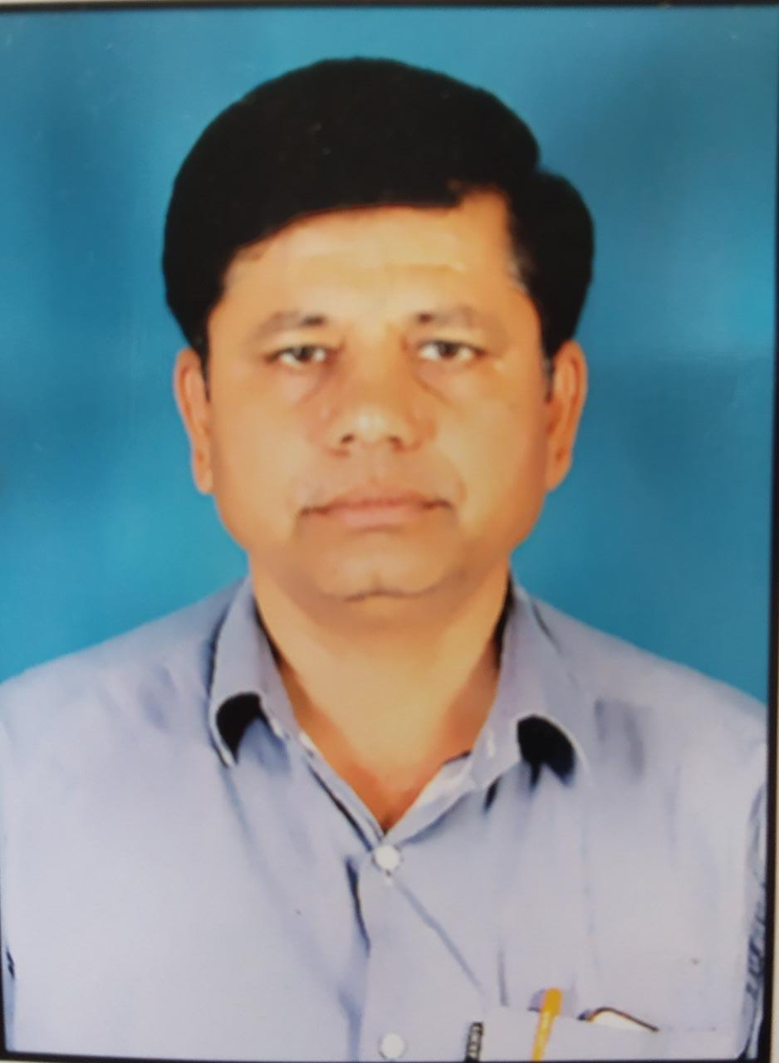
ACADEMIC RECORD:
- Ph.D. : Registered
- Title of Thesis : Ecological Issues: Ecocritical and Ecofeminist Study of Anita
Desai Select Novels
- M. A. : May 1992 , Shivaji University, Kolhapur
- B. A. : May 1990 , Arts and Commerce College, Madha.
Affiliated to Shivaji University, Kolhapur
TEACHING AND ADMINSTRATIVE EXPERIENCE: |  | - Total Teaching Experience : 25 yrs  - Total Teaching Experience for U.G : 25 yrs  - Total Teaching Experience for P.G. : 10 yrs  - Total Research Experience : 10  - Controller of Examinations : 00
RESEARCH AREA OF INTEREST |  | 1. Ecological Issues and Environment  2. Communication Gap  3. Linguistics
AWARDS, HONORS, SCHOLARSHIPS & FELLOWSHIPS : NIL
RESEARCH RECORD AS A  M. Phil./ Ph.D. |  |  | NIL
PAPER PUBLISHED IN THE NATIONAL AND INTERNATIONAL JOURNALS |  |  |  | International : 07  National : 02
PAPER PRESENTED IN NATIONAL/INTERNATIONAL CONFERENCES /SYMPOSIA/SEMINARS/WORKSHOPS |  |  |  | International : 09  National : 15
NATIONAL/INTERNATIONAL CONFERENCES / SYMPOSIA / SEMINARS / WORKSHOPS ATTENDED |  |  |  | International : 00  National : 12
REFERENCE BOOKS /BOOKS CHAPTER PUBLISHED WITH NATIONAL/ INTERNATIONAL PUBLISHERS |  |  |  | International : 00  National : 00
Text Books Published with National Publishers |  |  |  | NIL
RESEARCH PROJECTS | Ongoing : NIL  Completed : 01
SKILLS AND EXPERTISE :
- Soft skills
- Grammar
- ICT enabled Teaching

