Rayat Shikshan Sanstha’s
Arts and Commerce College,
Madha, Tal. Madha, Dist.-Soalpur-413 209
FACULTY PROFILE

Name : Smt. K. D. Bagul  Designation : Director of Physical Education  Department : Physical Education and Sports  Specialization : Atheltics  e-mail : bahiram241@gmail.com  Telephone :  Mobile No. : 9850422531 |  |  |  |  | 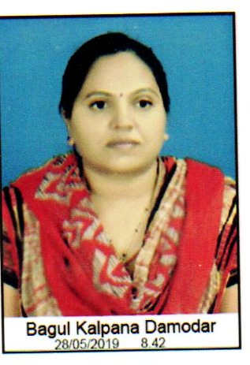
ACADEMIC RECORD:
- Ph.D. : Nil
- Title of Thesis :
- M. P.Ed. : April 2012, Pune University, Pune
- B. P. Ed. : April 2008, Pune University, Pune
- B. A. : April 2005, Pune University, Pune
- NET/SET : SET 2003

TEACHING AND ADMINSTRATIVE EXPERIENCE: |  | - Total Teaching Experience : 01  - Total Teaching Experience for U.G : 01  - Total Teaching Experience for P.G. : 00  - Total Research Experience : 00  - Controller of Examinations : 00
RESEARCH AREA OF INTEREST |  | 1. Physical Fitness  2. Yoga  3. Athelitcs
AWARDS, HONORS, SCHOLARSHIPS & FELLOWSHIPS : NIL
RESEARCH RECORD AS A  M. Phil./ Ph.D. |  |  | NIL
PAPER PUBLISHED IN THE NATIONAL AND INTERNATIONAL JOURNALS |  |  |  | International : 00  National : 01
PAPER PRESENTED IN NATIONAL/INTERNATIONAL CONFERENCES /SYMPOSIA/SEMINARS/WORKSHOPS |  |  |  | International : 00  National : 01
NATIONAL/INTERNATIONAL CONFERENCES/SYMPOSIA/SEMINARS/ WORKSHOPS ATTENDED |  |  |  | International : 00  National : 01
REFERENCE BOOKS /BOOKS CHAPTER PUBLISHED WITH NATIONAL/ INTERNATIONAL PUBLISHERS |  |  |  | International : 00  National : 00
Text Books Published with National Publishers |  |  |  | NIL
RESEARCH PROJECTS | Ongoing : NIL  Completed : NIL
SKILLS AND EXPERTISE :
- Yoga
- Athelitcs
- Other games

FEATURED PUBLICATIONS DURING LAST FIVE YEARS: NIL
(Add publications having impact Factor more than 2 or more than 2)

